A PROJECT REPORT

On

Safety Training Management App

Submitted in requirement of Industrial Training at JSW Dolvi Works.

**Submitted By** Preetam B. A. BE-IT (3rd Year)

Pillai College of Engineering, New Panvel- 410 206

## Guided By

Mr. R N Joshi (HOD IT Department) Mr. M V Raman (IT Department)

Mr. Ram Sunder Singh (IT Department)



**Department of Information Technology Department of Information Technology JSW STEEL Ltd. DOLVI WORKS PILLAI COLLEGE OF ENGINEERING**

## Dolvi, Pen - 402107 New Panvel – 410 206



**Department of Information Technology JSW STEEL Ltd. DOLVI WORKS**

## Dolvi, Pen - 402107

To Whomever it may concern

This is to certify that the requirements for the application entitled ‘**Safety Training Management App**’ has been successfully completed by **Mr. Preetam B A** in fulfillment of Industrial Training completed during the Year 2019 – 2020.

The project has been successfully submitted to the following signatories:

Date: 02/01/2020

## Mr. R N Joshi Mr. M V Raman

(HOD, IT Department ( IT Department,

JSW Steel Ltd. Dolvi Works) JSW Steel Ltd. Dolvi Works)



**Department of Information Technology PILLAI COLLEGE OF ENGINEERING**

**New Panvel – 410 206**

# Acknowledgement

This industrial training in JSW (Jindal Steel Works) Dolvi, Maharashtra, in Information Technology Department was a memorable one for me as it was rich in experience sharing and helped me to discover my potential. I had so many rich experiences and opportunities that I personally believe will forever shape and influence my professional life while fostering personal growth and development.

In this report, I hope to highlight the work that I have performed and learned. Working here has not only given me the industrial experiences, but also teaches me how to sustain in tough environment. Good working conditions and friendly behaviour of everyone inspires me to be productive in work.

These few details lead me to realize that, like all human endeavours, this report is not perfect and may contain errors and shortcomings. Thus, I remain open to all criticisms and suggestions which could present me with new sources of inspiration as I develop in my ability to research and learn.

This report would not have been possible without the contribution and collaboration of others. My sincere gratitude:

* Mr. R N Joshi, HOD, IT, JSW Dolvi.
* Mr. M V Raman, IT, JSW Dolvi.
* Mr. Ram Sunder Singh, IT, JSW Dolvi.

I am grateful towards Training Department, JSW Dolvi Works for considering me eligible and giving me the opportunity to showcase my talent and learn new skills.

To all of you, I extend my deepest gratitude and always owe my respect to them.

# Table of Contents

|  |  |  |
| --- | --- | --- |
| **Sr. No.** | **Content** | **Page No.** |
| 1 | History | 5 |
| 2 | Introduction | 6 |
| 3 | Java Server Pages(JSP) | 7 |
| 4 | JSP Syntax | 8 |
| 5 | Java Servlet | 9 |
| 6 | Detailed Approach - 1. Login Page | 11 |
| 7 | Detailed Approach - 2. New User | 12 |
| 8 | Detailed Approach - 3. Forgot Password | 13 |
| 9 | Detailed Approach - 4. About Page | 14 |
| 10 | Detailed Approach - 5. Safety Registration Page | 15 |
| 11 | Detailed Approach - 6. View Report Page | 16 |
| 12 | Database | 18 |
| 13 | Security Check | 20 |
| 14 | Deployment | 21 |
| 15 | Conclusion | 22 |

**History**

JSW Steel Ltd. is an Indian [steel](https://en.wikipedia.org/wiki/Steel) making company based in [Mumbai, Maharashtra](https://en.wikipedia.org/wiki/Mumbai%2C_Maharashtra). It is a subsidiary of [JSW Group](https://en.wikipedia.org/wiki/JSW_Group). It is one of the fastest growing companies in India with a footprint in over 140 countries. JSW Steel is an Indian steel company owned by the JSW Group based in [Mumbai, Maharashtra](https://en.wikipedia.org/wiki/Mumbai%2C_Maharashtra), India. JSW Steel, after merger of ISPAT steel, has become India's second largest private sector steel company. The current installed capacity is 18 MTPA. A $13 billion conglomerate, with presence across India, USA, South America & Africa, the JSW Group is a part of the O.P. Jindal Group with strong footprints across core economic sectors, namely, Steel, Energy, Infrastructure, Cement, Ventures and Sports.

In 1994, Jindal Vijayanagar Steel (JVSL) was set up with its plant located at Toranagallu in the [Bellary](https://en.wikipedia.org/wiki/Bellary)-Hospet area in the State of [Karnataka](https://en.wikipedia.org/wiki/Karnataka), the heart of the high-grade iron ore belt and spread over 10,000 acres (40 km2) of land over a decade.

The 5 MTPA integrated steel plant at Dolvi, Maharashtra majority stake acquired in 2010, is an inherent part of JSW Steel. This is Indian's first and only operating CONARC Technology plant.

The Dolvi plant caters to several industries including automotive, projects and construction, machinery, LPG cylinder-makers, cold rollers, oil and gas sector and consumer durables.

Unique features:

* + The Dolvi plant is the first in India to adopt a combination of Conarc technology for steel making and compact strip production (CSP) for producing hot rolled coils. The main feature of CSP is thin slab casting.
  + It can produce coils with thickness as low as 1.0 mm.
  + HR coils produced at Dolvi are feed material for the two JSW Steel cold rolling and downstream facilities at Vasind , Tarapur and Kalmeshwar

# Introduction

Maintaining the data may sometimes become a lot hectic when it comes to be updated daily. Many still prefer to use traditional applications such as Microsoft Excel and maintain number of spreadsheets to manage the data. **Safety Training Management App** is a project is regarding the attempt to solve this problem by designing a database centric Web Application which can help in ‘Easy - Entry’ and ‘Easy - Access’ of the data.

The solution contains an ‘Entry Form’ where the details of the trainees are entered. The solution also contains a ‘View Report’ page which displays the data based on the parameters filled in the form. This will prove beneficial when it comes to viewing only a specific data when required. The app also has the feature to export the data displayed on the page into an Excel file making a smooth integration with the current technique through which the entire process is managed currently.

The app is based on MVC (Model View Architecture) architecture. The look and feel of the page is also maintained by using Bootstrap and Custom CSS to provide some amazing design to the page. The page is built using Java (Servlet and JSP) acting as the controller. The database is an Oracle database providing the Industry-Standard Data Management and Secured Techniques acting as the model.

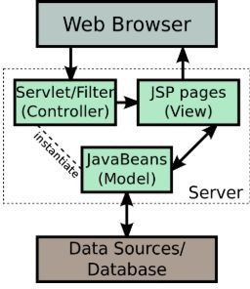

# JSP – Java Server Pages

Java Server Pages (JSP) is a server-side programming technology that enables the creation of dynamic, platform-independent method for building Web-based applications. JSP have access to the entire family of Java APIs, including the JDBC API to access enterprise databases.

Architecturally, JSP may be viewed as a high-level abstraction of Java servlets. JSPs are translated into servlets at runtime, therefore JSP is a Servlet; each JSP servlet is cached and re-used until the original JSP is modified.

JSP can be used independently or as the view component of a server-side model–view–controller design, normally with JavaBeans as the model and Java servlets (or a framework such as Apache Struts) as the controller. This is a type of Model 2 architecture.

JSP allows Java code and certain predefined actions to be interleaved with static web markup content, such as HTML, with the resulting page being compiled and executed on the server to deliver a document. The compiled pages, as well as any dependent Java libraries, contain Java bytecode rather than machine code. Like any other Java program, they must be executed within a Java virtual machine (JVM) that interacts with the server's host operating system to provide

an abstract, platform-neutral environment.

JSPs are usually used to deliver HTML and XML documents, but through the use of OutputStream, they can deliver other types of data as well.The Web container creates JSP implicit objects like request, response, session, application, config, page, pageContext, out and exception. JSP Engine creates these objects during translation phase.

# JSP Syntax

JSP pages use several delimiters for scripting functions. The most basic is

<% ... %>, which encloses a JSP scriptlet. A scriptlet is a fragment of Java code that is run when the user requests the page. Other common delimiters include <%=

... %> for expressions, where the scriptlet and delimiters are replaced with the result of evaluating the expression, and directives, denoted with <%@ ... %>.

Java code is not required to be complete or self-contained within a single scriptlet block. It can straddle markup content, provided that the page as a whole is syntactically correct. For example, any Java if/for/while blocks opened in one scriptlet must be correctly closed in a later scriptlet for the page to successfully compile.

Content that falls inside a split block of Java code (spanning multiple scriptlets) is subject to that code. Content inside an if block will only appear in the output when the if condition evaluates to true. Likewise, content inside a loop construct may appear multiple times in the output, depending upon how many times the loop body runs.

# Java Servlet

A Java servlet processes or stores a Java class in Java EE that conforms to the Java Servlet API, a standard for implementing Java classes that respond to requests. Servlets could in principle communicate over any client–server protocol, but they are most often used with the HTTP. Thus "servlet" is often used as shorthand for "HTTP servlet". Thus, a software developer may use a servlet to add dynamic content to a web server using the Java platform.

The generated content is commonly HTML, but may be other data such as XML and more commonly, JSON. Servlets can maintain state in session variables across many server transactions by using HTTP cookies, or URL mapping.

The Java servlet API has, to some extent, been superseded by two standard Java technologies for web services:

* The Java API for RESTful Web Services (JAX-RS 2.0) useful for AJAX, JSON and REST services, and
* The Java API for XML Web Services (JAX-WS) useful for SOAP Web Services.

To deploy and run a servlet, a web container must be used. A web container (also known as a servlet container) is essentially the component of a web server that interacts with the servlets. The web container is responsible for managing the lifecycle of servlets, mapping a URL to a particular servlet and ensuring that the URL requester has the correct access rights.

The Servlet API, contained in the Java package hierarchy javax.servlet , defines the expected interactions of the web container and a servlet. A Servlet is an object that receives a request and generates a response based on that request.

The basic Servlet package defines Java objects to represent servlet requests and responses, as well as objects to reflect the servlet's configuration parameters and execution environment.

The package javax.servlet.http defines HTTP-specific subclasses of the generic servlet elements, including session management objects that track multiple requests and responses between the web server and a client. Servlets may be packaged in a WAR file as a web application.

Servlets can be generated automatically from JavaServer Pages (JSP) by the JavaServer Pages compiler. The difference between servlets and JSP is that servlets typically embed HTML inside Java code, while JSPs embed Java code in HTML.

While the direct usage of servlets to generate HTML (as shown in the example below) has become rare, the higher level MVC web framework in Java EE (JSF) still explicitly uses the servlet technology for the low level request/response handling via the FacesServlet.

A somewhat older usage is to use servlets in conjunction with JSPs in a pattern called "Model 2", which is a flavor of the model–view–controller.

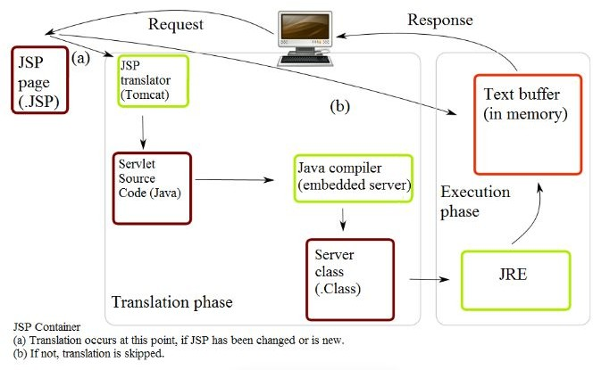

Detailed Approach

## The Login Page:

This is the page, user sees when he/she opens the app. It is normal login page through which the user can access the actual web app. The user is required to enter the user id and password mandatorily. The app ensures it by displaying the message to enter the respective fields. When the user id or password doesn’t match, the user will get the warning message regarding mismatch of the user id or password.

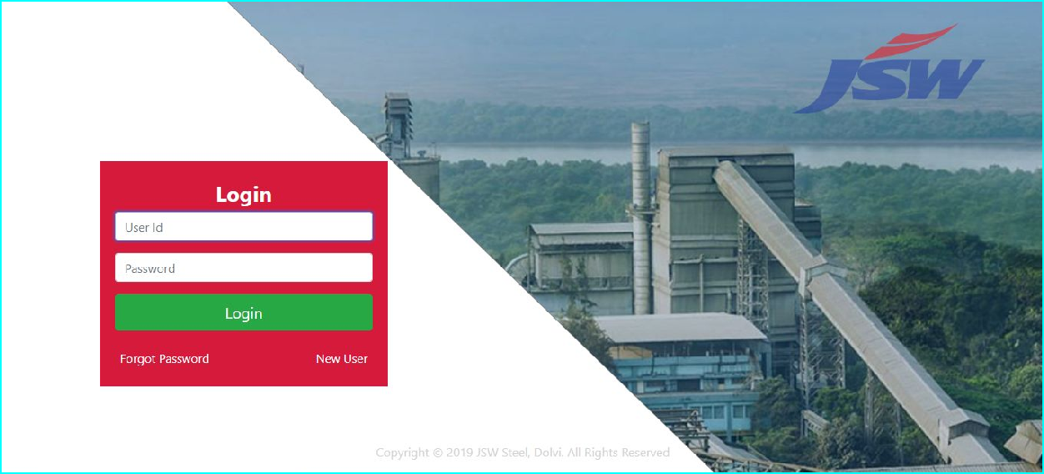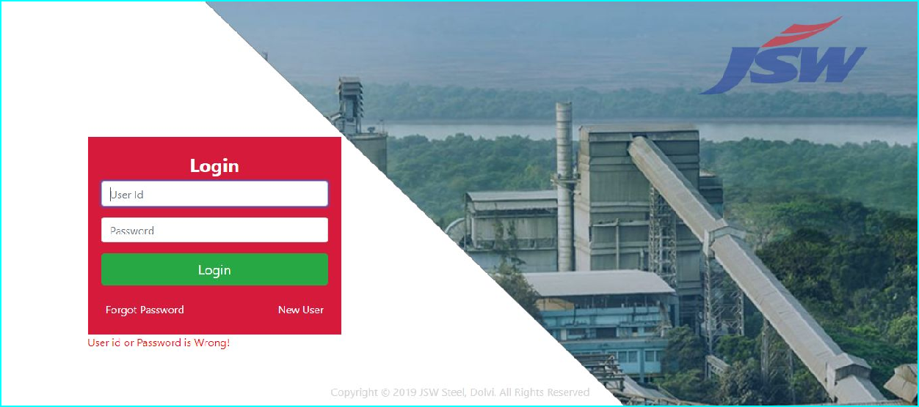

## New User (Registration):

If a new employee wants to register himself as a new user, he can do so by registering himself through the form. A user has enter his/her UserID/Employee ID , his/her name, Date of Birth and Password.

After the registration is completed, the user will get the message regarding the status of registration.

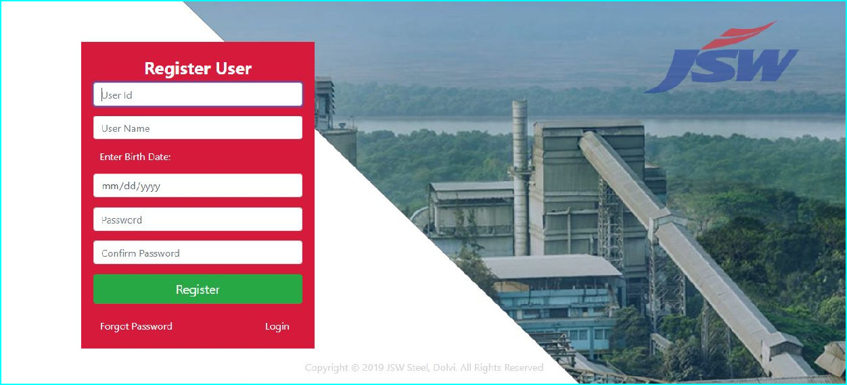

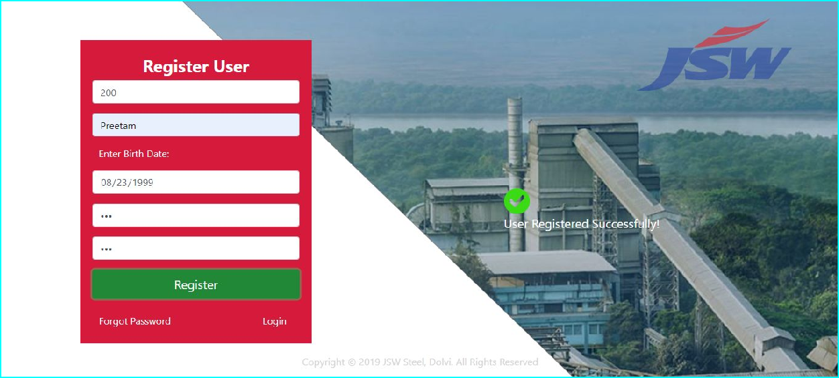

## Forgot Password:

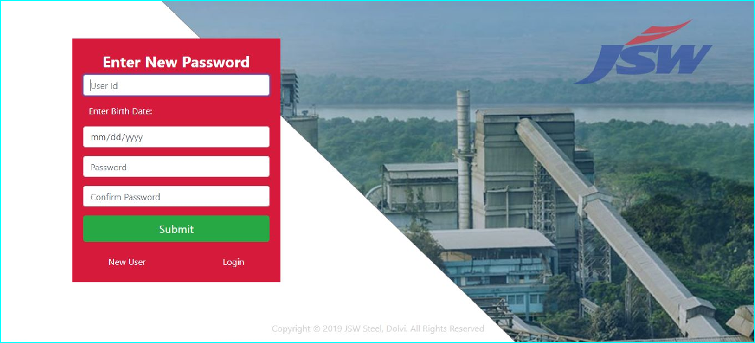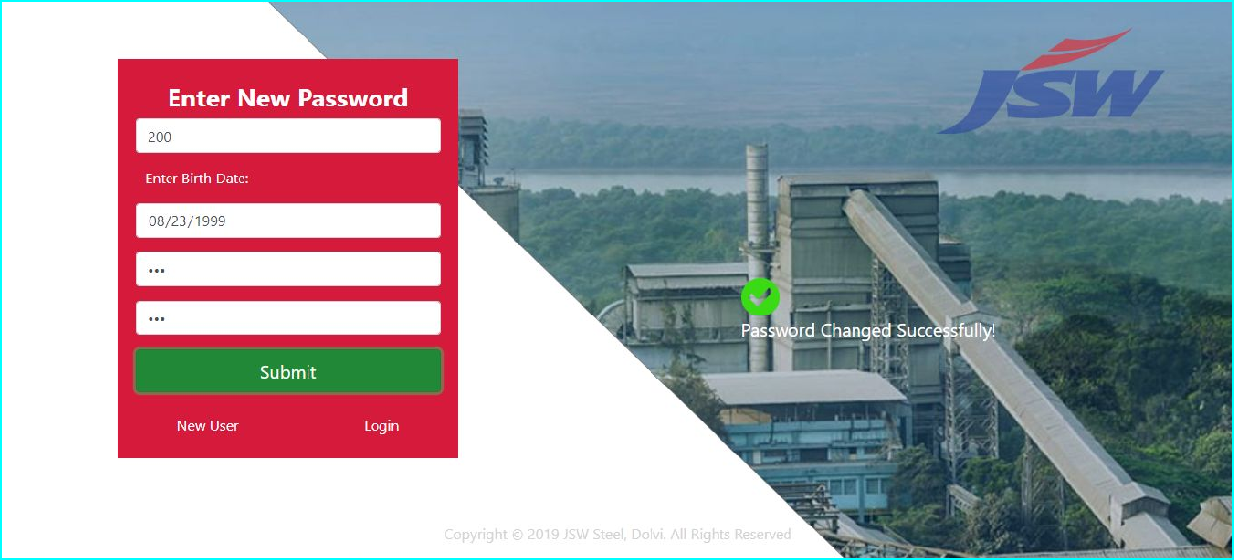There may be the conditions where the existing user forgets his/her password. In such conditions he/she can click on the Forgot Password Link. The system will check whether the database contains the BirthDate corresponding to the respective user. If the credentials match then, the password against the user is changed. If the credentials doesn’t match then the password will not be updated.

## About Page:

After logging into the system, the user will be served with the ‘About page’, where the user will get to know a brief information about the portal. The page can also be accessed without logging in and the option for Login instead of Logout will appear in the navigation bar.

The About page is necessary to showcase the user about the system along with its capabilities and to understand the portal better. The navigation bar contain links to the Different Pages which can only be accessed after successfully log in. The links are as follows:

* 1. Registration: Opens the registration page containing the form to enter the details about.
  2. View Report: The button redirects to the page where the details regarding the training can be fetched.
  3. Logout: The button destroys the session created using while logging in and redirects to the login page.



## Safety Registration Page:

After clicking on the ‘Registration Page’ button, the user will be redirected to the page shown below. The registration page also contains an interactive navigation bar which redirects to the links mentioned in the menu page. Here the user has to enter 4 mandatory details before submitting the form. The four mandatory fields are as follows:

* 1. First Name
  2. Last Name
  3. Training Date
  4. Training Type

The other values aren’t mandatory and can be filled as per the requirement.

* + 1. User may enter safety passport No. or Employee No.
    2. Address can be filled in Address Text Area
    3. Vendor Name can be filled in Vendor Name Input Text Field.
    4. PO number can be entered in its respective field.
    5. Department and their HOD
    6. Location and Faculty
    7. Plant

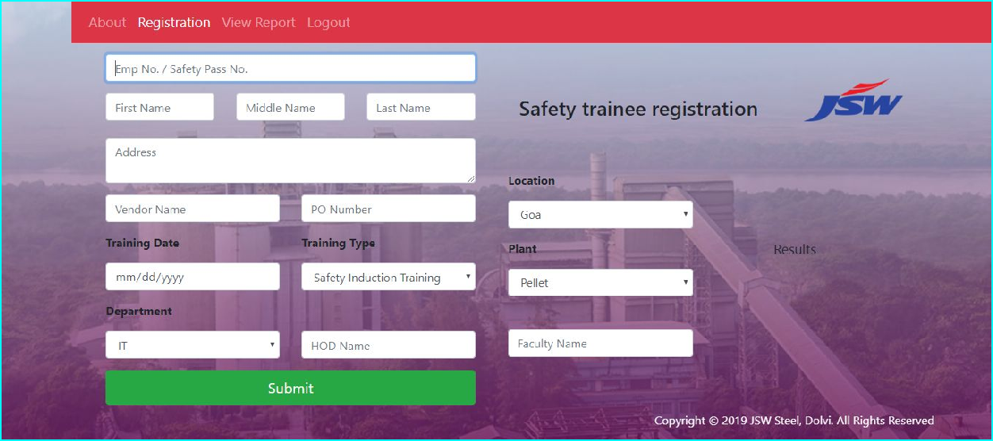

## View Report Page:

In this page, user can retrieve the details by applying various filters as mentioned in the figure below. Here the user has to mandatorily enter the ‘Training Date FROM’ and ‘Training Date TO’. After entering these values, all the details between those dates will be displayed.

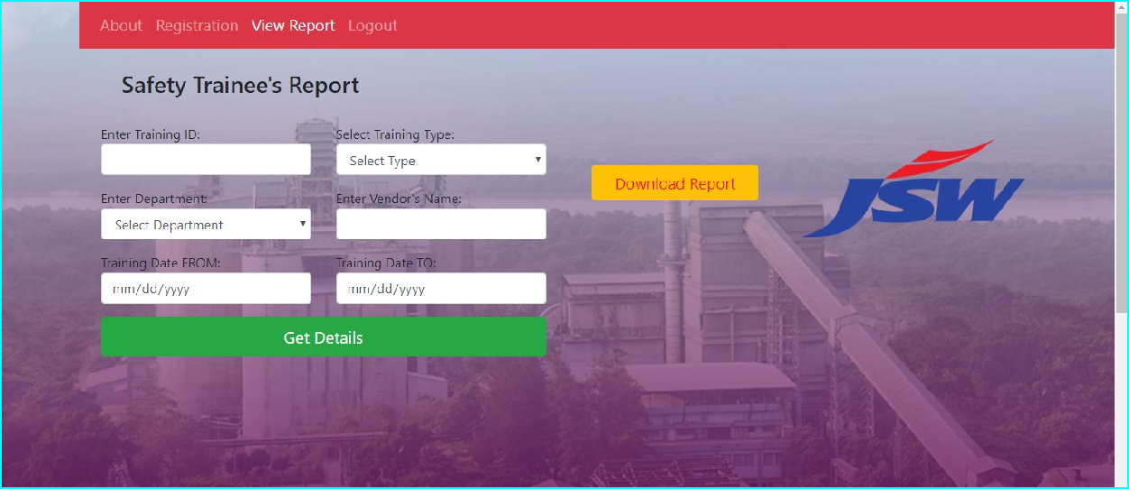

After entering another value of the parameter. All the details between the entered dates having that Parameter’s value will be displayed in the Table format below the form.

Download Report Button: Upon clicking the button all the data available in the table below the form will be exported to the excel format. The excel formatted will thus be downloaded into the system. The feature was necessary, considering the fact that the organization was previously using Excel Sheets to maintain the data.This feature will ensure a smooth transition which when fails may allow users to shift to the excel worksheet when necessary.

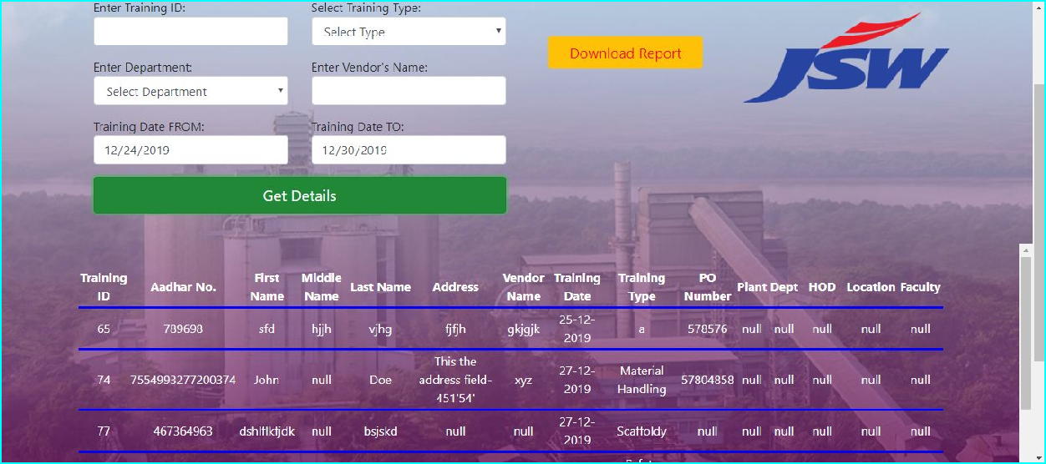

# Database

The Database used for this application is Oracle 11g Express Edition. Free to develop, deploy, and distribute:

Oracle Database 11*g* Express Edition (Oracle Database XE) is an entry-level, small-footprint database based on the Oracle Database 11*g* Release 2 code base. It's free to develop, deploy, and distribute; fast to download; and simple to administer.

Table Details:

1. Safety Details Table Table Name: SAFETY

Following are the details of the columns used in the table along with the constraints mentioned. The table also includes a sequence which can be used to auto-increment the values of the column ‘SRNO’ and doesn’t need to be inserted manually by the user.

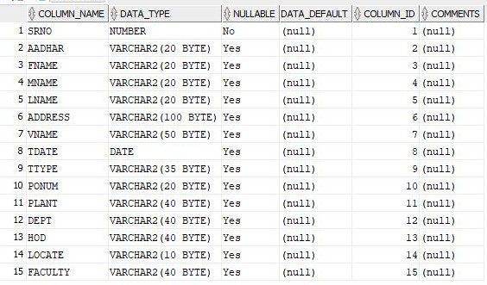

1. User Table

Table Name: USER_PASS

It is the table which the system refers while logging into the system. Whenever a user creates a new account, his details are stored in this table.

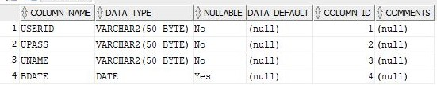

1. Training Type Table

Table Name: TRTABLE



These types of master tables are maintained for Plant, Department and Location in addition with respective table names:

* 1. PLANT
  2. DEPT
  3. LOCATE

. The Select option references these tables to Display the options dynamically.

# Security Check

1. **SQL Injection:** SQL injection is a web security vulnerability that allows an attacker to interfere with the queries that an application makes to its database. It generally allows an attacker to view data that they are not normally able to retrieve. This might include data belonging to other users, or any other data that the application itself is able to access. In many cases, an attacker can modify or delete this data, causing persistent changes to the application's content or behavior.

The Application prevents the attack by using Prepared Statements while executing the SQL Lines.

1. **Unauthorised Access:** Even though the login page acting as a Gate Secures from entering into the System, it may sometimes be bypassed by manually entering the URL to that page. The system secures the unauthorised breach by maintaining the session attributes throughout the session until the user logs out from the system.

This means when no user is logged in, no one can access the other pages by manually entering the URL. In that case, the user will be automatically be redirected to the login page.

# Deployment

Server Used: **Apache Tomcat V9.0**

The Apache Tomcat® software is an open source implementation of the Java Servlet, JavaServer Pages, Java Expression Language and Java WebSocket technologies. The Java Servlet, JavaServer Pages, Java Expression Language and Java WebSocket specifications are developed under the [Java Community Process](http://jcp.org/en/introduction/overview).

The Apache Tomcat software is developed in an open and participatory environment and released under the [Apache License version 2](http://www.apache.org/licenses/). The Apache Tomcat project is intended to be a collaboration of the best-of-breed developers from around the world. Tomcat provides a "pure [Java](https://en.wikipedia.org/wiki/Java_(programming_language))" [HTTP](https://en.wikipedia.org/wiki/Hypertext_Transfer_Protocol) [web server](https://en.wikipedia.org/wiki/Web_server) environment in which [Java](https://en.wikipedia.org/wiki/Java_(programming_language)) code can run.

Apache Tomcat software powers numerous large-scale, mission-critical web applications across a diverse range of industries and organizations.

The Deployment can be easily done using Eclipse IDE through which the project files in WAR format are imported and care should be taken that path to suitable Tomcat Server is set under the Server Section in Eclipse IDE.

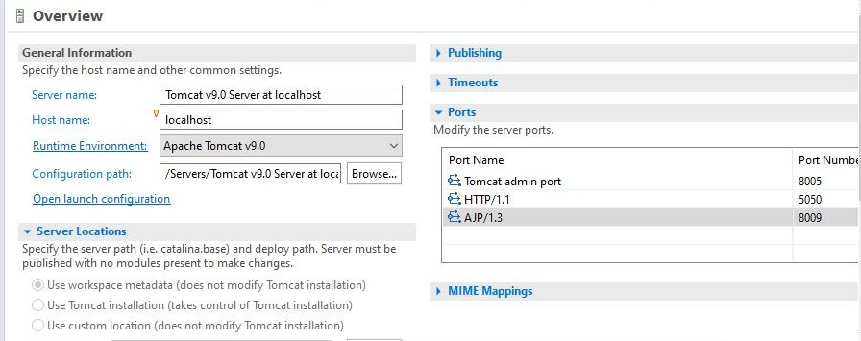

# Conclusion

I can honestly say that my time spent in training with JSW Steel, Dolvi resulted in one of the best experiences of my life. Not only did I gain practical skills but I also had the opportunity to meet many fantastic people. The atmosphere at the office was always welcoming which made me feel right at home. Additionally, I felt like I was able to contribute to the company by assisting and working on projects throughout the internship.

I am grateful for allowing my application to be deployed on their servers and hope to contribute in making the process easier in the process.

Overall, my training at JSW Steel, Dolvi has been a success. I was able to gain practical skills, work in a fantastic environment, and make connections that will last a lifetime. I could not be more thankful.